**INTRODUCTION**

Students Management System is to provide an option to maintain student’s record or information at one place without any fear of losing data. This software if not only store the data or information of the students in the database but also capable of managing it.

Student Management System is specially designed for Schools and Colleges to maintain their records of students at one place. This software helps schools and colleges security of their student’s data or information.

Student Management System is provide security to the student’s data or information by giving access of the software only to the administrator. No one else cannot access these software unless he/she has credentials of administrator. So student’s data or information is always safe and secure within these software.

Student Management System is very easy and convenient to use for administrator because of the user friendly user interface of the software. Administrator can add or remove student’s data any time he/she want as per its convenient. This is a fully offline software, so it cannot be used at another system unless doing setup of the software. So the data is safe and secure within this software.

**PROBLEM DEFINITION**

**MODULES :**

* **Splash Screen :**
  + In the Splash Screen Module, there is screen showing title of the project and showing some graphics to the user and welcome them to the system.
* **Admin Login :**
  + In the Admin Login Module, there is a login form containing username and password for the login. And it also has a exit button to close the application.
* **Menu :**
  + In the Menu Module, there is a menu screen which shows three menus 1.Student Information 2.Add New Student and 3.Edit New Student and it also has Logout button to logout and go to the Admin Login Page.
* **Students Information :**
  + In the Students Information Module, there is a grid view which shows the information of all students which is stored in the MS-Access database. And it also has Menu and Logout Button.
* **Add New Student :**
  + In the Add New Student Module, there is a form containing Full name, mother name, date of birth, etc. and many more fields to add new student data in the database. And it also has Data Grid View to display the Students Information. And it also has Menu and Logout Button.
* **Edit Student Details :**
  + In the Edit Student Details Module, there is a form like add new student data to do modification in the previously saved data. You can delete and update the data in this module.

**OBJECTIVES :**

* The objective of the Students Management System is to make maintenance of the Student’s data or information easier.
* Another objective is to get rid of the paper books and switch to the digital database system.
* Student Management System is help to make students data or information safe in the MS-Access database.
* The main objective of the Student Management System is to make storing and maintain data easier and safe.
* To make maintaining a student’s data easier, safe and secure for everyone.

**SYSTEM ANANLYSIS :**

Systems Analysis and Design, an interdisciplinary part of science, may refer to Systems analysis, a method of studying a system by examining its component parts and their interactions. Structured data analysis (systems analysis), analyzing the flow of information within an organization with data-flow diagrams.

Systems design, the process of defining the architecture, components, and data of a system to satisfy specified requirements. Object-oriented analysis and design, an approach to analysis and design of an application, system, or business that emphasizes modularity and visual modeling.

**EXISTING SYSTEM**

In the existing system of students management, the records of all students are maintained in peper books. They are very difficult to manage. If you want find anyone’s record you have to search whole books. It is a very time consuming job. Sometimes records has been damaged so you can recover the records of the students. It is a very high maintainance job to keep all student’s records in books. It is a very work to do for records.

**Drawbacks of Existing System :**

* It is very time consuming job in existing students management system.
* Sometimes Records are damaged so you cannot find the record of the student.
* Need more time to find the record of the particular student from all the records maintained in the books.
* Most of the work is manually done by authorized person.
* If the data entry get wrong then need to enter whole data of students in new record.

**PROPOSED SYSTEM**

The proposed system will solve all the problems they are facing now. This software is designed to maintain all students record at one place in MS-Access database. In this software data is secure and safe in a system so it will not be lost.

The aim of proposed system is to develop a system of improved facilities. The proposed system can overcome all the limitations of the existing system. The existing system has several disadvantages and many more difficulties to work well. The proposed system tries to eliminate or reduce these difficulties up to some extent. The proposed system will help the user to reduce the workload and mental conflict.

**HARDWARE AND SOFTWARE REQUIREMENTS**

**Hardware Requirement :**

Processor : Intel Dual Core 2.0 GHz or more

RAM : 512 MB or more

Hard Disk : 80 GB or more

**Software Requirement :**

Front End : Visual Basic 6.0

Back End : MS-Access

Operating System : Windows

**TECHNOLOGY USED**

Microsoft intended Visual Basic to be relatively easy to learn and use. Visual Basic was derived from BASIC, a user-friendly programming language designed for beginners, and it enables the rapid application development (RAD) of graphical user interface (GUI) applications, access to databases using Data Access Objects, Remote Data Objects, or ActiveX Data Objects, and creation of Active controls and objects.

A programmer can create an application using the components provided by the Visual Basic program itself. Over time the community of programmers developed third party components. Programs written in Visual Basic can also use the Windows API, which requires external function declarations.

VB defines default attributes and actions for the components, a programmer can develop a simple program without writing much code. Programs built with earlier versions suffered performance problems, but faster computers and native code compilation has made this less of an issue. Though VB programs can be compiled into native code executables from version 5 on, they still require the presence of around I MB of runtime libraries. Core runtime libraries are included by default in Windows 2000 and later, but extended runtime components still have to be installed. Earlier versions of Windows (95/98/NT), Require that the runtime libraries be distributed with the executable.

**DATABASE USED**

**Using MS-Access:**

MS access is powerful multi-user DBMS developer by Microsoft corp. it can be used to store and manipulate large information and automate repetitive task, such as maintaining an inventory and generating invoices.

Data in Access is organized in the form of table. Within a table, record are arranged according to a common reference value, known as the primary key or the key field. The value in the key field is different for every record and thus helps in uniquely identifying records.

A combination to two or more field can also be used as the primary key, such a combination is called a composite key. Since a value in one table can be replication across other tables, there should be a way to maintain a relation is implemented through the concept of foreign key.

The Microsoft access is a much versatile database which allows link to related information easily. It perfectly act as DBMS and RDBMS package. It complements other databases because it has several powerful connectivity features. Access can directly work with data from other sources, including many popular PC database program such as database and paradox, with database on desktops, on servers, on minicomputer or on mainframes, and with data stored on internet or internet web servers. Access also fully supports Microsoft's Active X technology, so an Access application can be either a client or a server for all the office application including Microsoft's Word, Excel, Power point, Outlook, Frontage and others.

**DATABASE DESIGN**

We have design a MS-Access database to build the Students Management System. MS-Access is a very powerful database. We have connected our Students Management System to the MS-Access Database to maintain Students data or information in it. We have created appropriate data field with their datatype. You can see in the data fields and their datatypes in the following pictures.

This is a Design view of MS-Access database which is connected to the project :

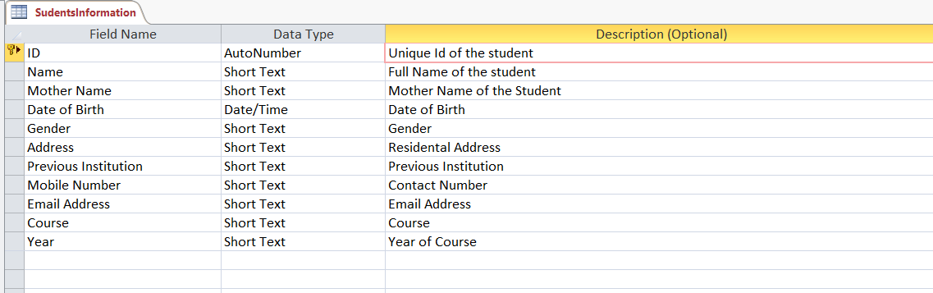

This is with some data inputted in the MS-Access database :

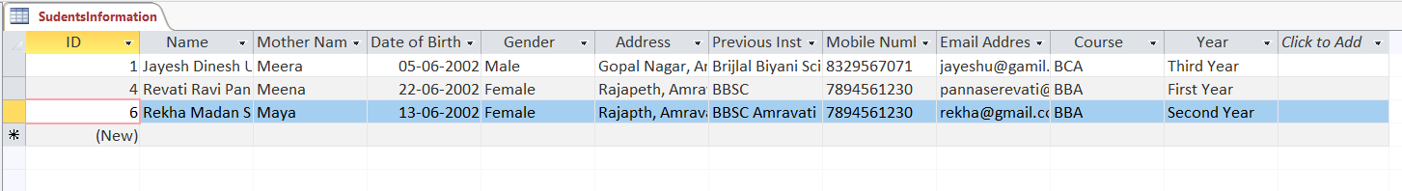

**SYSTEM DESIGN**

**Data Flow Diagram (DFD) :**

The Data Flow Diagram of the Students Management System is as follows:

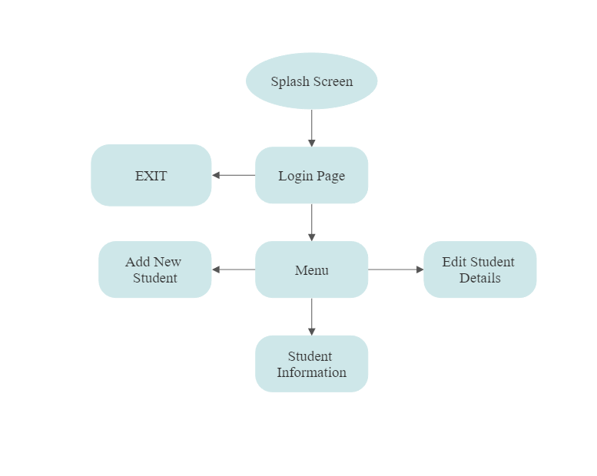

**CODING AND FORMS**

**Splash Screen :**



**Code :**

Private Sub Timer1_Timer()

Timer1.Enabled = False

Unload Me

Login.Show

End Sub

**Admin Login :**

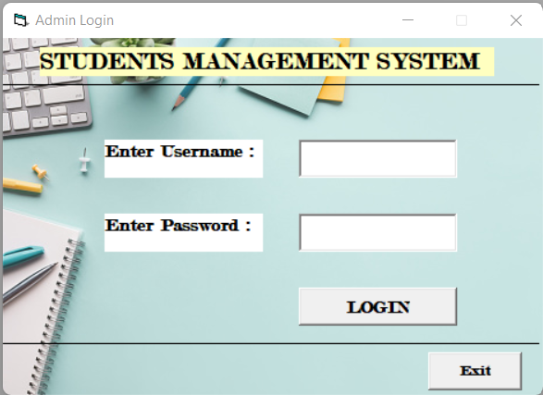

**Code :**

Private Sub Command1_Click()

If Text1.Text = "admin" And Text2.Text = "Pass123" Then

Me.Hide

Menu.Show

Text1.Text = ""

Text2.Text = ""

Else

MsgBox "Enter Correct Credientials!", vbInformation, "Error"

End If

End Sub

Private Sub Command2_Click()

Unload Me

End Sub

**Menu :**

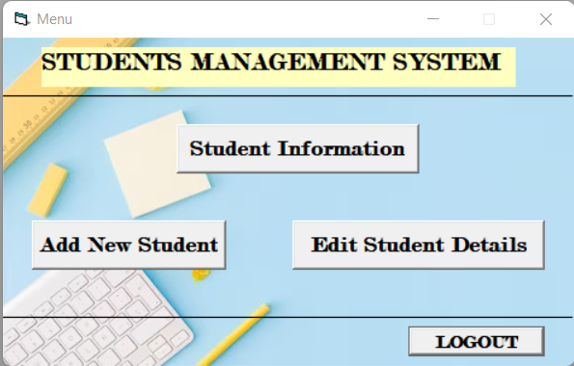

**Code :**

Private Sub Command1_Click()

Login.Show

Unload Me

End Sub

Private Sub Command2_Click()

stdInfo.Show

Unload Me

End Sub

Private Sub Command3_Click()

NewStd.Show

Unload Me

End Sub

Private Sub Command4_Click()

EditStd.Show

Unload Me

End Sub

**Students Information :**

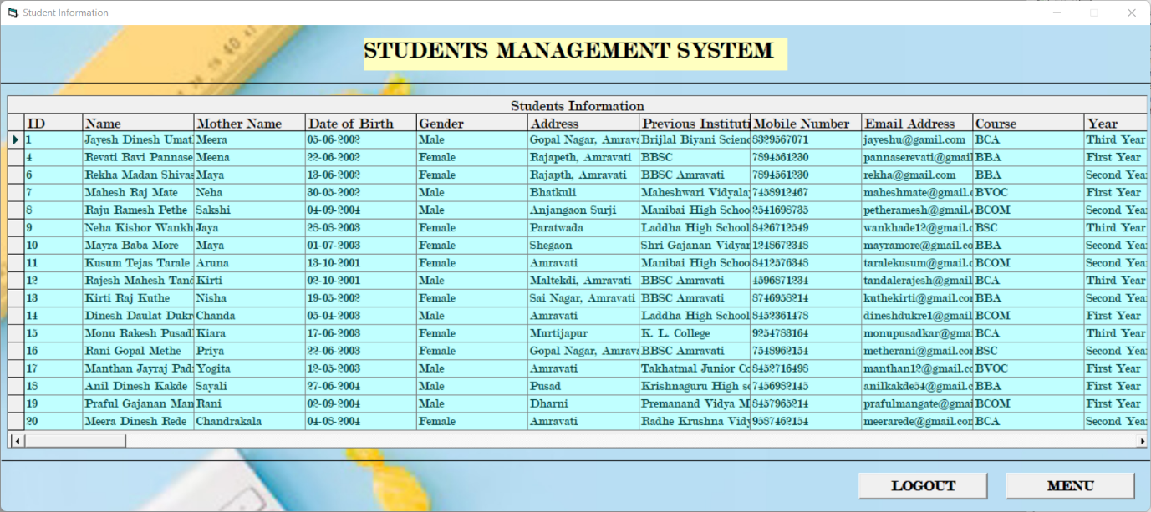

**Code :**

Private Sub Command1_Click()

Login.Show

Unload Me

End Sub

Private Sub Command2_Click()

Menu.Show

Unload Me

End Sub

**Add New Student :**

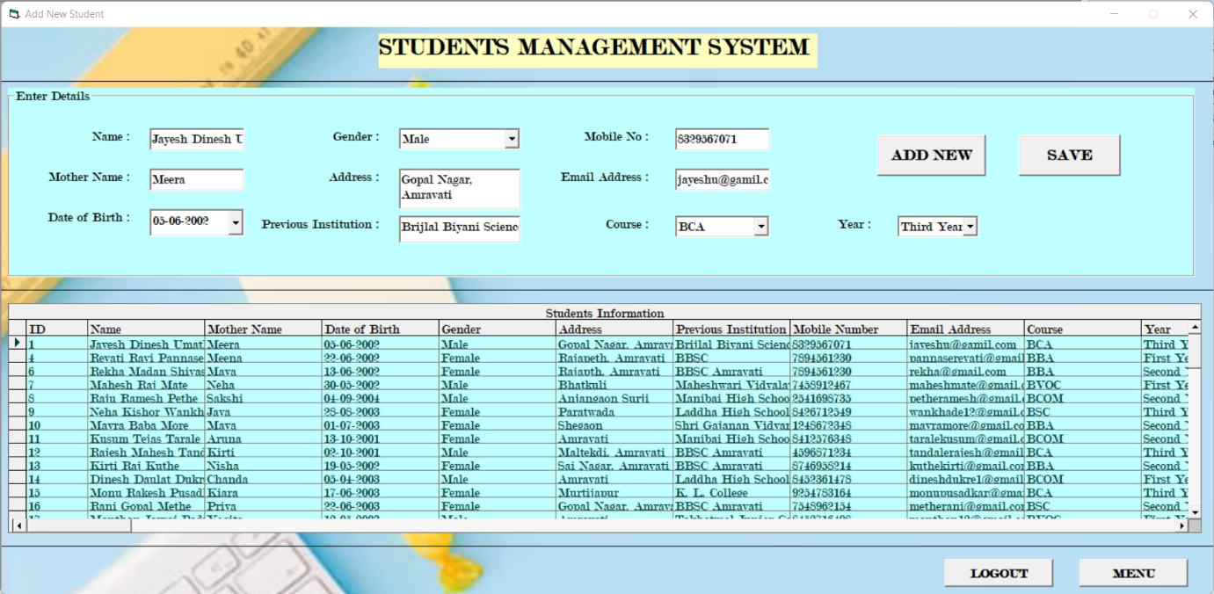

**Code :**

Private Sub Command1_Click()

stdInfo.Recordset.AddNew

End Sub

Private Sub Command2_Click()

stdInfo.Recordset.Update

End Sub

Private Sub Command3_Click()

Login.Show

Unload Me

End Sub

Private Sub Command4_Click()

Menu.Show

Unload Me

End Sub

**Edit Student Details :**

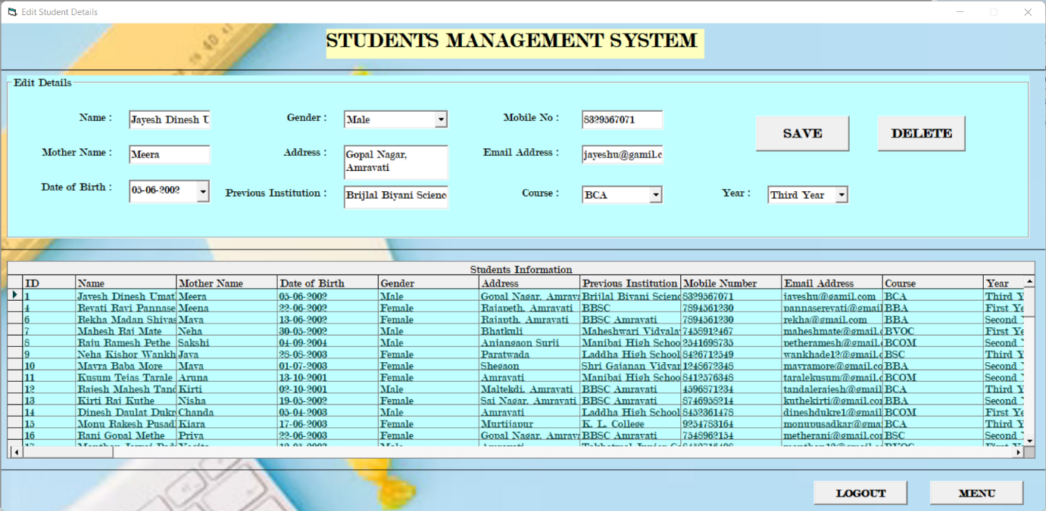

**Code :**

Private Sub Command1_Click()

stdInfo.Recordset.Update

End Sub

Private Sub Command2_Click()

answer = MsgBox("Do you want to delete this record?", vbExclamation + vbYesNo, "Confirm")

If answer = vbYes Then

stdInfo.Recordset.Delete

Else

MsgBox "Cancelled", vbInformation, "Confirm"

End If

End Sub

Private Sub Command3_Click()

Login.Show

Unload Me

End Sub

Private Sub Command4_Click()

Menu.Show

Unload Me

End Sub

**ADVANTAGES AND DISADVANTAGES**

**Advantages :**

* Students Management System is easy and convenient to use for everyone.
* This system cannot be accessed by any other person or intruder than administrator.
* Administrator can have access of all student’s information.
* So, he/she can able to add new student in the database.
* Administrator can also edit or delete any student’s record.
* It is very easy to get information of all students at one click using Student Management System.

**Disadvantages :**

* Students Management System cannot be accessed remotely because it is a fully offline software.
* Unable change the credentials of administrator by yourself. You need to do changes in a code.
* Unable to store profile photo of student in database.

**FUTURE SCOPE**

Students Management System is going to very useful for Schools and Colleges to maintain a data of all students. This system provides high security for data. This system is fully offline system so no one can access your student’s data.

Students Management System is help to maintain the student’s data or information in a secure MS-Access Database. In this software only administrator have access to data means only he/she can make changes in data. So in future to get rid of manual record book this system is going to be used in every schools and colleges.

**CONCLUSION**

Thus looking at the present system it is found that the versatile project of “Students Management System Project” gives us the innumerable benefits over the traditional system and greatly handling and management of the data or information of the students in very systematic, efficient and flexible manner.

**REFERENCE**

**Website :**

* www.stackoverflow.com
* www.google.com
* www.learn.microsoft.com

**Books :**

* Musturing VB 6.0 Block Book -Peter - NMaston-Techmedia
* Guide VB6.0 Block Book -Peter-Norton – Techmedia
* Microsoft Access Programming- Robert Mutia Low